Working Paper 09/0X

GIS Applications for Fire and Rescue

Service Operations in Montpellier, France

Yves Jazeron¹ and John Stillwell²

¹ Service Départemental d’Incendie et de Secours de l’Hérault, Forecasting Service,
624 rue de l’agathois, 34080 Montpellier, France
Tel : +33 (0)4 67 03 35 59;
Email: yves.jazeron@pa.sdis34.fr

² School of Geography, University of Leeds, Leeds LS2 9JT, United Kingdom
Tel: 0113 343 3315;
Email: j.c.h.stillwell@leeds.ac.uk

June 2009

CONTENTS

ABSTRACT

LIST OF FIGURES

- INTRODUCTION
- FIRE AND RESCUE SERVICES IN THE HERAULT
- ORGANISATION AND DESCRIPTION OF THE METHOD
- RISK ASSESSMENT
- THE FUTURE DEVELOPMENTS OF GIS
- CONCLUSION

ENDNOTE

REFERENCES

LIST OF FIGURES

1 The distribution of fire and rescue service centres in Hérault

2 Communes covered by SDIS34
3 Example of the outcome of digitizing the roads between land parcels, commune of Saint Gély du Fesc
4 Extract of aerial photograph covering part of western Montpellier
5 Example of the digitized road hierarchy in the commune of Saint Gély du Fesc
6 The cone of fire propagation
7 Extract from GIS database: area of potential flooding overlaid on the principal roads and threatened houses
8 Flooding of the River Les in Montpellier, 2003

9 The distribution of fire and rescue operations in the commune of Montpellier, 2006

10 Scattergraphs of incidents against unemployment, no diploma and immigration

ABSTRACT

Despite the increasing availability of satellite navigation systems for guiding service vehicles to key locations, hard copy maps are still required to provide guidance to the fire and rescue services across France. Accurate map sheets are reliable and do not break down. Over the last five years, the Service Départemental d’Incendie et de Secours in Montpellier has been using geographical information systems to create maps for operational use by their fire crews. This paper explains the methodology used to create these maps based on cadastral data. It also discusses the organizational and technical means by which major risks such as forest fires and floods are identified and finally, it demonstrates the embryonic use of GIS for spatial analysis of fire and rescue incidents.

Keywords: Fire incidents; maps; geographic information system; risk; forest fire; flooding.

1 INTRODUCTION

Geographic information systems (GIS) are sets of computer tools that can support spatial decision-making but also provide a means of communication of information in a wide range of applied contexts (Burrough, 1986; Stillwell and Scholten, 1990; Maguire, 1991; Longley et al., 1999; Lo and Yeung, 2007). This paper outlines how a GIS is being used in combination with mapping methods to support the daily activities of the fire and rescue service in the city of Montpellier in the Languedoc-Rousillon region of southern France. In order to be efficient and effective, the Service Départemental d’Incendie et de Secours de l’Hérault (SDIS34) requires the rapid identification and management of major risks and relies on the existence of accurate and reliable maps to guide the fire engines and other service vehicles to incidents in the minimum amount of time. This is necessitated because the global positioning systems (GPS) of the in-built satellite navigation systems may lose contact with the satellites when travelling along narrow streets and have to recomputed the optimum route several times. As a consequence, service vehicles may miss important turnings or junctions, thereby increasing travel times to attend incidents. Moreover, the availability of laminated hard copy maps in the vehicles means that there is a reference base always available that the vehicle drivers and navigators can trust.
Historically, the Fire Station Headquarters of Montpellier used maps that were made from copies of the street map of the commune of Montpellier, and more general plans for the small contiguous communes for whom service were also provided. However, these maps were inaccurate and became increasingly out-of-date with the rapid demographic expansion and urban/suburban development taking place in the city in recent years. In 2004, the SDIS34 adopted GIS as a means to generate more reliable maps using digital land parcel (cadastral) data from the Tax Services Directorate (www.impots.gouv.fr), orthophotographs and aerial photographs from Gaïa Mapping (www.gaiamapping.com), and CORINE land cover data (www.ifen.fr/donIndic/Donnees/corine/presentation.htm).
The Forecasting Service of SDIS34 has also used GIS to support its work on the prevention of fires in the future. Identification of possible hazards is an essential prerequisite for planning how to tackle risky incidents when they arise. An ESRI GIS, combining cadastral and local fire service data, helps to determine response activities and how to evaluate how successful they are (CADCORP, 2007 slide 23). The structure of the Forecasting Service is in two parts: administrative and operational. The administrative part involves collecting and digitising various types of information as follows.

- Identification of the locations of the fire-hydrants for the improvement of defense against fire. These locations are stored in the GIS.
- Participation in the Local Urban Plan (PLU) that sets the general rules for land use, and the Schéma de COhérence Territorial (SCOT), the framework for coherent territorial planning. The local authorities send SDIS34 their new PLU and SCOT documents in order to seek advice about civil security matters. SDIS34 are also invited to participate in public meetings in each commune to talk about these issues. Data from the updated plans are digitized and stored in the GIS in order to update maps for use in the operations. They can also be used for spatial analysis (e.g. overlaying flooded areas) and forecasting the type of operations that might occur so that the fireman are informed about which areas are threatened.
- Involvement in granting of building permits, e.g. for housing estates or concerted development zones (ZACs) or installations classified for environmental protection (ICPE). The same explanation applies for buildings. Moreover, SDIS34 has the legal obligation to inform the local authorities where to install fire hydrants and where are the main gates/access points for buildings, as well as the number, size and height of buildings and the number of households living inside buildings. These data are added to the GIS and are used for operations and for local planning projects such as the development of the city’s tramway (line three). Indeed, the route of the tram line runs along main roads, sometimes in the middle, sometimes on one side, and it can be an obstruction to small streets or the main gates of buildings. SDIS34 works with the public transportation services in Montpellier to guarantee permanent access. A 20 metre buffer around the route of the third tram line has been created in the GIS and a list is kept of the public and principal buildings (containing a lot of households) located within the buffer zone.
- Fieldwork to identify buildings with different types of risks which are subsequently stored in the GIS.
The operational part involves the creation of a communal atlas dedicated to operations and the mapping of facilities such as industrial plants, factories, public buildings and camp sites. The atlas includes a location map, architectural drawings, a map of the motorways (access, gate of service, a map of the location of special events or gatherings, information about the railway network (including level crossings) and the location of lakes and ponds (Teng, 2006).
After providing a short contextual introduction to the region and to the organisation of the fire and rescue service, the paper explains how GIS is being applied to produce maps that support the daily operations using data on land parcels from the cadastre since this is more accurate than any other spatial information that is available. The paper then discusses how the GIS is providing information about the risks associated with locations in relation to forest fires and floods. Finally, the paper demonstrates how the GIS can be used in future for spatial analysis of the incident or operations data.

2 FIRE AND RESCUE SERVICES IN THE HERAULT

The Département de l’Hérault is the thirty-fourth of France’s 100 départements, comprising 343 communes covering 6,101 square kilometres and containing a population of almost one million inhabitants. The permanent population has grown from 794,603 inhabitants in 1990 to 982,000 in 2005, and the Herault contains two large agglomerations: Montpellier, the capital city has a growth rate of 10% per year; and Béziers is growing at 33.5% per year. Communes on the coast such as Agde, Sète and La Grand-Motte are growing in size and are becoming increasingly important. The populations of each of the coastal communes increase tenfold during the summer holiday period due to seasonal tourism and second home ownership. The two classified ‘Seveso’ factories (EU industrial safety regulations are known as the Seveso II Directive 96/82/CE) in Béziers and Sète are important risk locations as are the airports at Mauguio (contiguous with Montpellier) and Béziers. Sète is the main port for fishing and transport of freight and passengers and there are important transport arteries aligned from east to west: the A9 motorway, National Road 113, the railway, the inland waterway canal from the Rhône to Sète and the Canal du Midi which passes Béziers on its way to the Mediterranean. The A75 motorway runs northwards to Paris, crossing the Tarn by way of the Millau Viaduct. From north to south, the Hérault landscape is composed of Mediterranean dry mountains which decline to the plain (the Midi) with vineyards and then to the etangs bordering the sea.
The SDIS34 is composed of 72 fire stations distributed as throughout the département as shown in Figure 1. The service employs nearly 800 professional firemen, more than 3,000 volunteer firemen and more than 150 administrative and technical territorial civil servants. It maintains 1,000 vehicles and undertakes nearly 60,000 operations a year, one every nine minutes on average. The SDIS34 Chief defines the missions which fall to the firemen within the framework of the protection of people, goods and the environment. With regard to the operational cartography and GIS, the achievements include an atlas of communes, plans of indexed establishments, a wall map for crisis management and the computerization of the Centre for Emergency Calls (CTA) on the Système d’Information et de Gestion de l’ALErte (SIGALE) which is the management and information system for emergencies (Kacenelen, 2006). When the CTA receives a phone call relating to an emergency, the operator sends the relevant geographic data (the address of the incident) to the Montpellier fire station and the appropriate map is identified for the firemen to use.

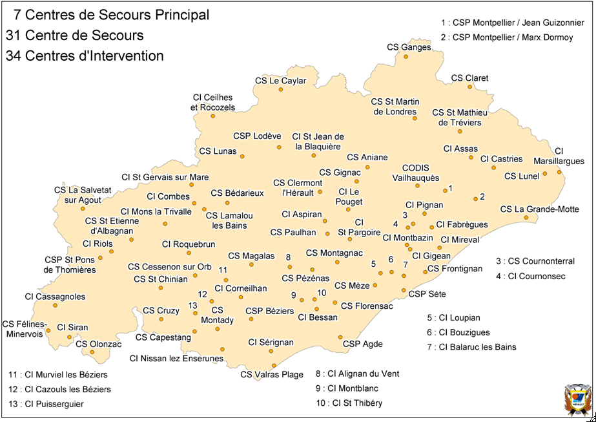

Figure 1: The distribution of fire and rescue service centres in Hérault

In the early sixties, France hosted thousands of immigrants coming from north Africa (Algeria, Tunisia and Morocco) after the independence of these countries. During this time, the French Government built many high-rise apartment blocks in the suburbs of the major towns. A lot of people arrived in Languedoc-Roussillon and particularly in Hérault. Employment opportunities reinforced the region’s attractiveness, although the unemployment rate remained higher than the national average. Local authorities had to develop suitable housing policies. Montpellier was at the forefront of this development and experienced a population growth from 91,300 in 1954 to 244,500 inhabitants in 2004, according to a census in January 2004 (SCOT of the Agglomération de Montpellier, 2006).
The local authorities have spatial tools with which to make plans for housing, roads infrastructure, protection of natural areas, agricultural activities, leisure and well-being according to the sustainable development based upon the Kyoto agreement signed in 1997. The SCOT is a document that defines, for 10 to 20 years, the major axes for regional planning. It fixes the limits between the urban areas or those assigned for urbanisation on the one hand, and the natural and agricultural areas on the other. It organises, in space and time, the conditions of the sustainable development of the départemental territory.
This dynamic demographic context, for which the SCOT provides the spatial planning strategy, requires a fire and rescue service that is well organized and a SDIS34 Forecasting Service that has a good computer infrastructure. There are five networked computers: three at the fire-station Jean Guizonnier (north of Montpellier) and two at the fire-station Marx Dormoy (south of Montpellier). These two fire-stations represent the headquarters of Montpellier which covers the 21 (‘first call’) communes. However, the fire service may also be required to provide cover for a further 24 (‘second call’) communes. This only happens when the firemen of the areas concerned are already committed to other operations and request more vehicles. Statistics for recent years show that the Montpellier area accounts for approximately 25% of operations in the Département of Hérault. There are 100 firemen based at each of the two stations in the city; they are divided in three teams of 25-27 men, plus the volunteers. Ten officers work in the forecasting and operational services; in addition, 20 clerical, administrative and technical civil servants are working in the services. Each fire station covers roughly half of Montpellier and all the communes on its respective side. The number of operations can vary from 10,000 to 15,000 per annum. There are 26 vehicles for all types of operations, 60% to 70% of which are rescue operations and that is why four ambulances and two medical cars are needed. Over the summer, the number of operations increases because of the forest fires that occur during the dry season and because there are more people resident within the coastal areas. Forty more volunteers are employed during the summer period.

.

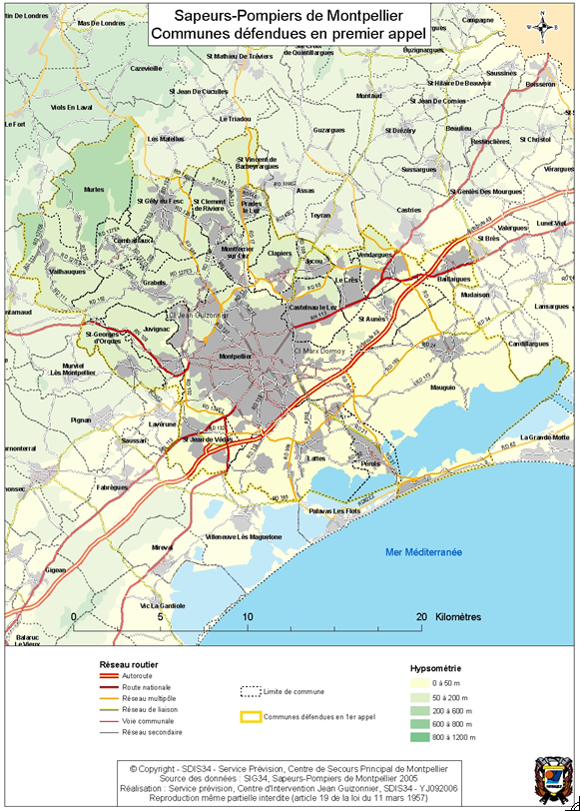

Figure 2: Communes covered by SDIS34

3 ORGANISATION AND DESCRIPTION OF THE METHOD

The Forecasting Service for Hérault is in charge of creating the atlas of communes for the fire service operations. In order to create maps for the firemen to use in their operational duties, the SDIS34 initially needed to decide in which GIS software to invest. In the early 2000s, most of the local authority services in the Hérault had chosen to work with ArcGIS; the data exchange between all these institutions was easier because they were all running the same software. This is essentially why SDIS34 decided to adopt ArcGIS. In fact, other SDISs have adopted ArcGIS and some are much more advanced in their applications than the SDIS34 which is currently at the stage of establishing GIS foundations for future development. So the choice of ArcGIS was partly to facilitate data exchange with other local authorities who were already working with this package, but it was also chosen because it represented good value for money. Furthermore, ESRI has an office in Montpellier within easy reach so there is good local support available for advice
An atlas is required in order to have an accurate presentation of the geographical information represented at a detailed scale (1:5,000); hence several map pages are necessary to represent the area within the territorial boundary of each commune. Maps of eight to ten communes are represented in one folder which must have a series of components:

- an administrative card with information about the commune (e.g. addresses and phone numbers of the mayor, electricity and water companies, technical staff) in case of a major event;
- a synopsis, references and signature – information about who produced the maps, references of the origin of the data, contact addresses and phone numbers;
- a communal cutting, legend and description – the number of pages, the legend and some explanation about particularities of the commune concerned;
- a roadmap of the commune showing roads subject to flooding;
- a topographic map, extracted from Institut Géographique National (www.ign.fr) with relief and forests;
- a streets index which is a gazetteer;
- a localities index which and includes the names of all localities and neighbourhoods (e.g. La Mosson, Le Millénaire, Aiguelongue); and
- a key structures/buildings/sport area index which includes details of all buildings such as city hall, schools, hospitals and industrial premises.

The need to have accurate up-to-date maps made it necessary for SDIS34 to acquire the land register digitised by the GIS and cartography service of the Conseil Général of Hérault (CG34). This is produced by CG34 as a reference coverage in their GIS, mainly for use in urban and regional planning in close participation with the communes who are modifying their PLUs. It is thus used to map the precise location of the land parcels and the constructions associated with planning in the event of natural or technological catastrophe. The SDIS34 use it mainly to create the atlas, but also to find access to buildings in the town centre (to identify yards and narrow streets, for example) and to trace urban development over time. The CG34 digitises the cadastral maps (Plan Minute de Conservation) provided by the Tax Services Directorate from the Ministry of Economy, Finance and Industry. The cadastre gives accurate and reliable boundaries of the land parcels in each commune although no information was provided with the digital boundary data about land ownership. The cadastre in France dates back to Napoleonic times and is the base for land taxes; hence it is the property of the Tax Services Directorate. The cadastre is divided into communes, with each commune being subdivided in sections, and each section divided into boards. The boundaries of land parcels are mapped for each board, together with the buildings/constructions and other taxable information such as swimming pools, second garages, new extensions, et cetera. Streets, rivers and streams are also represented as geographical objects with their names as attributes. Once the digitised cadastral data have been validated and ratified by the Tax Services Directorate, the cartography service of CG34 sets up conventions with various partners for the provision of the land register for each commune. Normally, each convention costs 10% of the value of the digitisation of the commune concerned but the agreement between SDIS34 and CG34 for data exchange was without cost. One advantage of this arrangement is that free data, updated annually, are provided by CG34 and the accuracy and precision of the coordinates are maintained.
At the SDIS34, geodatabases are then built containing the annotations of the names of: roads/streets, key buildings and the hydrographic network, as well as numbers of roads, plans and squares. Shapefiles are also created containing the arcs of the roads/streets by category, hydrants, buildings, key buildings, size of streets for the trucks, and land uses. The most important shapefiles contain the arcs of roads created by using the cadastral layer at the 1:1,000 scale. This is a critical step in the process. The arcs are digitized so as to represent the roads as the open spaces between the parcels, as indicated in Figure 3, which shows the outcome of this process for part of one commune, Saint Gély du Fesc.

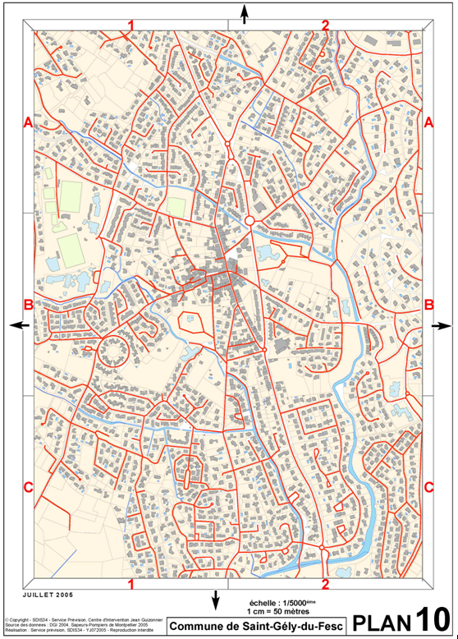
Figure 3: Example of the outcome of digitizing the roads between land parcels, commune of Saint Gély du Fesc

Thereafter, aerial photographs are used to check and confirm the position of the streets and buildings. These data are particularly useful because the photographs have been taken between August and November 2005, with a Leica camera, at an altitude of 2,000 metres, providing a very accurate image of the territory. As shown in Figure 4, buildings, infrastructure, land cover and roads are easily identifiable. The size of each pixel is equal to 20 centimetres on the ground. The extract in Figure 4 shows an area to the east of Montpellier and to the south of a ‘quartier’ known as La Mosson (formerly La Paillade), with buildings that include the Montpellier football stadium, the Stade de La Mosson. The contribution of the aerial photograph is very important in the precision of the digitization from the overlay of the land parcel coverage.

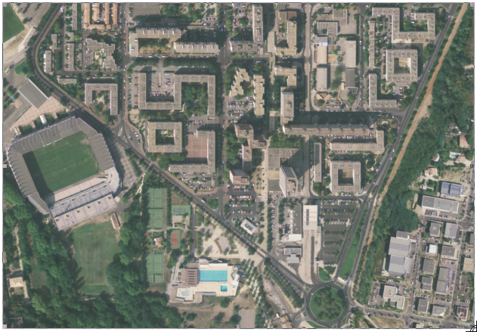
© Gaïa Mapping - 2005

Figure 4: Extract of aerial photograph covering part of western Montpellier

The arcs of the roads provide the base of the creation of other geographic layers. Indeed, from these arcs we can generate the street network as shown in Figure 5 for the commune of St Gely du Fesc in order to create an index of all the roads with tables using relational data in Microsoft Access.
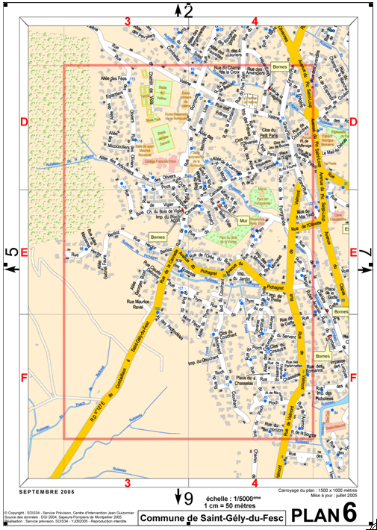
Figure 5: Example of the digitized road hierarchy in the commune of Saint Gély du Fesc

The arcs of the roads layers are digitised in a geodatabase corresponding to the commune and all the attributes are added and stored in a .dbf file which can be opened in MS Access. A page can be printed with all the coordinates. Each time the geodatabase file is updated, the page in MS Access ready for printing is updated too. This has the advantage of establishing dynamic connections which allow automatic updating. The housing density associated with the digitised land parcels can be clearly observed in Figure 5. Roads of different sizes are created using the buffering tool in ArcGIS. Motorways are identified with a 20 metre buffer, main roads with a 15 metre buffer, minor roads with a 10 metre buffer and small vehicle trails with a buffer of 5 metres. The sizes of the buffers are determined by the need for a representation of the road names that are legible on the 1/50,000 scale maps since the names have to be written within each buffer. Moreover, the buffer size has to represent reality, i.e. so as to avoid hiding polygons representing buildings located alongside the roads.
The time that it takes to develop an atlas for a particular commune depends on the size of the commune and its land cover. Montpellier is the largest area with 5,706 hectares whereas Saint Jean de Védas (1,316 hectares), Saint Clément de Rivière (1,270 hectares) and Juvignac (1,081 hectares), for example, are much smaller. It takes, on average, four months of full-time work to create a communal atlas including:

- digitizing the street arcs, hydrants, buildings, fields, land use and hydrography;
- categorizing the roads;
- checking on the ground by driving round by car and by meeting urban planners in the different communes;
- validation by each local authority (by the urban planning service and signed by the mayor) giving approval to the work and meaning that this tool is accepted as a part of the civil security for the citizens in the commune;
- validation by a senior offices at the SDIS34 once it has been validated by the mayor of the commune; and
- printing the atlas, informing the teams of firemen about the atlas, and putting the atlas in the different vehicles that the firemen use.

The ground truthing exercise can take a lot of time depending on the size of the commune and usually requires two people. Montpellier has 2,900 roads covering 680.95km, for example, whilst Juvignac has only 182 roads covering 93.03km. Because it is such a time consuming task, the SDIS34 should have more people working on this; the publication of the atlas can be delayed simply because of the time spent on checking the roads.
Atlases (Service Prevision Centre de Secours Principal de Montpellier, 2009) are created with maps of all communes which are placed in the fire service vehicles and are also held in the Centre de Traitement de l’Alerte (CTA), where emergency calls are received. The atlases are produced for each fire station in different colour folders: a blue folder with all the communes in the south-east of the city and a red folder with the communes of the north-east. Only the commune of Montpellier has one atlas because of its size. However, each street is mentioned in the gazetteer with the corresponding sector. A single atlas is created for Montpellier which includes 69 plans at the 1:5,000 scale, and additional plans for the town centre at the 1:2,500 scale. The same plans are laminated and have a relevant street gazetteer on the reverse side, in order to make them easier to use and more resilient. An atlas for each commune is also kept in the planning room next to the call centre office of the fire station. Finally, a wall plan by commune, in A0 format (84 x 118.8 cm ≈ 1 m²), is produced at the 1:6,000 scale. The wall plan gives a general and comprehensive view of the commune, in order to show the principal access routes, the potential problem areas (e.g. flooded zones) and the square tiles represented in the atlas. The firemen take a look at the wall plan before they leave the fire station, so that they can see in one glance the direction in which they have to go to the incident.
In addition to the atlases, an établissement répertorié (ER) is also created. This is an index of building plans and is composed of a preferred route into the building, a location plan which indicates the safety perimeter and an architectural drawing. ERs are not produced using the GIS although information about geographic locations and the recommended way to reach them from the fire stations is taken from the GIS. The ERs are drawn using Adobe Illustrator from the architect’s plans, simplified for the operations. One of the next steps will be to integrate the ERs into the GIS and at the Emergency Call Centre (ESRI, 2007, p. 26). This document is an essential resource for the chief of the fire crew in the vehicle attending the incident. The documents are used to assist decision making within the framework of the procedures used by the firemen to maximize security for all involved in the incident. The flexibility and dynamism of the ER is obtained by feedback from the firemen undertaking the operations. This is important in order to update the GIS and map production. In the case of the ERs, it is necessary to know whether the guidance is satisfactory for the operations (e.g. was there ladder access? Were any corridors obstructed? Was the elevator disabled?). The laminated paper plans are essential and will never be replaced by a system of handheld PCs because they are not fragile and never break down. In the near future, these ERs will be available at the Emergency Call Centre in Adobe Acrobat format in the first instance to be read on the screen by the operator, and printable if required. Thereafter, they will be part of the GIS.
Thus, the CTA of Montpellier is equipped with computers and the data of the communes come from the SDIS34 GIS. When someone in the city phones in an emergency, the person seated in front of the computer at the CTA can find the address among the streets index/gazeteer of the commune and then send the operation to the fire station concerned with details of the type of operation, the vehicle required, the address and the coordinates of the incident. This saves time to find where the operation takes place, on the paper atlas.
This section of the paper has outlined a technical method of creating sets of coverages in the GIS which are used to provide fire crews with maps to guide them to incidents. They are also used to inform the firemen as accurately as possible about the risks that they are likely to confront. Risks are particularly important when it has rained heavily and several roads maybe under water. A school might be on fire and the alert is received at the fire station. When this happens, a document is printed automatically with the name of the school, the address and the location coordinates. The chief of the fire crew will immediately look at the map on the wall, locate where the school is and which roads are potentially closed because of flooding. He will then obtain the folder of the ER of the school. There is a map of the best itinerary and a map of other buildings within a 500 metre perimeter that could be threatened. The map of the best itinerary is actually created previously by the GIS officer and included in the paper document; it is not just created when someone calls the fire department. Then the chief will look at the configuration of the school on the plans, inside and outside, and also locate the hydrants. In the next section, we turn more specifically to risk assessment.

4 RISK ASSESSMENT

In addition to risks associated with the built environment, the Languedoc region is also affected by two other sources of risk: forest fires and floods. Because risk management in operations is very different from situation to situation, SDIS34 recognises that there is potential for making use of GIS to assist decision making to mitigate risks. They want to develop ArcGIS, using tools such as 3Danalyst and Spatial Analyst (ESRI, 2007 http://www.esri.com/library/whitepapers/pdfs/gis-for-fire.pdf), to utilize the data sets currently held in the system for the assessment of major risks.
What is a major risk? A major risk is the possibility of an event occurring of natural or anthropogenic origin, whose effects can threaten a great number of people, causing damage which exceeds the capacity of the society to react effectively. Haroun Tazieff, a vulcanologist (1914-1998) who was Secrétaire d'Etat in the French Government between 1984 and 1986 and in charge of prevention of major risks, defined a major risk as “a threat on mankind and his direct environment, on his installations, a threat whose gravity is so important that society is absolutely exceeded by the vastness of the disaster” (http://www.prim.net/education/definition_risque_majeur/definition.html). For the last 15 years, authorities have tried to take better account of major risks in regional planning. So, for a better assessment of risk, it is necessary to consider various parameters such as: risk exposure, the number of houses and inhabitants, accessibility, the risk of another accident occurring on an operation, the setting up of a safety zone and the follow-up of the evaluation of the major risks incident. Risk assessment in society is necessary at all the stages of an operation. The different types of risk are grouped into five main categories:

- natural hazards: forest fire, flooding, ground movement, cyclone, storm, earthquake and volcanic eruption;
- technological risks: including industrial risks, hazardous materials, nuclear and biological risks and dam failures;
- transportation risks;
- risks of daily living: including domestic accidents and road accidents; and
- risks related to conflicts.

Forest fires and floods are among a number of natural risks classified by the French Ministry for Ecology and Sustainable Development that also include avalanches, cyclones, ground movements, storms, seismic shifts, volcanic risks and plate tectonics. There are also technological risks relating to dams, industrial plants, nuclear plants and radioactivity and the transport of dangerous substances. Natural events experienced in France in recent years include the storms of Christmas 1999, floods in the Somme and in Languedoc-Roussillon in 2002, 2003, 2005 and 2006, forest fires in south of France, and the explosion of the AZF chemical plant in Toulouse in 2001 and all show that the damage to society as well as to the local economy and physical infrastructure can be considerable. Forest fires start in several types of vegetation on a minimum surface of one hectare. France, with 15 million hectares, is the most wooded state of the European Union; 80% of forest fires in France start in the south-east because of the nature of the vegetation and climate. In 1989, a record of 75,500 hectares of forest were destroyed by fire; more than one million hectares of forest have been burnt since 1965. France has over than 6,000 fires each year. By a law in 1995, the State founded the Plan de Prévention des Risques (PPR) which aims to delimit the zones exposed to natural risks and to define necessary methods of prevention, protection and safety.
In some cases, fires are related to the socio-economic transformations of parts of the south of France which are associated with rural migration and decline of the sheep transhumance, dairy and other agricultural activities, the development of tourism, the spread of urbanisation (isolated housing) and of rubbish dumps. The climatic conditions (wind and humidity in particular) play an important role in the formation and the development of fires. In this case, it is advisable to integrate several parameters into a GIS to locate, monitor and track forest fires. One tool that is useful in this context is the cone of fire propagation (Figure 6), a plastic overlay that can be superimposed on a 1:25,000 scale map and used to observe the area of vegetation threatened by fire according to a particular weather forecast. By including this cone projection with raw data such as wind speed, type of vegetation, road infrastructure and overlaying on a digital elevation model (DEM), the fire officers have a decision support tool.

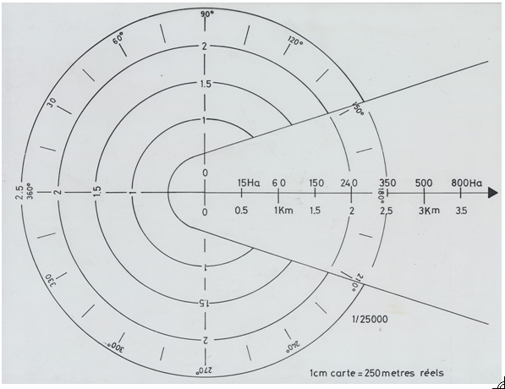
Figure 6: The cone of fire propagation

The speed of the fire propagation is given by the Etat Major de Zone (EMZ – zonal headquarters) based in Valabre (for the Mediterranean area), near Aix-en-Provence (Départment of Bouches-du-Rhône). Each day during the summer, the Wood and Agriculture Service sends a report on the hygrometry of the vegetation and the national weather forecasting agency send a state of the hygrometry in the air. The EMZ combines these data reports in order to classify the risk during the day in terms of high or low fire threat. Moreover, each mobile weather forecast station at the site of a forest fire also provides information. This station consists of a vehicle called the ‘Poste de Commandement Mobile’ and has three functions: transmission by radio (the job of the chief of transmission); management (carried out by the fire officers); and risk anticipation (undertaken by the chief of cartography). The cartography is used for risk assessment; to determine the whereabouts of wooded areas and houses threatened; and to analyse the landscape, elevation and topography (hill, river, agriculture land, natural vegetation).
According to the weather data provided, with windspeed being particularly important, the fire propagation cone can give predictions of the area of surface at risk of being burnt by the fire. The idea is to integrate this process into the SDIS34 GIS although it should be recognized that there are already tools for the simulation of fire propagation, such as the Fire Tactic software, used by SDIS13 in collaboration with Intergraph (http://www.intergraph.com/). This is software that calculates in real time the progression of the flames based on weather forecasts and topographic data. It has also been used by the fire services in Suffolk and Surrey in the UK (Drouet, 2003) and by the Research and Test Centre that belongs to the Interdépartementale Agreement for the Protection of the Forest and the Environment Against Fire (CEREN) in France.
Finally, in the context of the management of risk of forest fires, there already exists a paper atlas, the Défense de la Forêt Contre les Incendies (DFCI), which is used by the firemen and which is always available in the firefighting vehicles truck. The production of the atlas was coordinated by a public administration organization, the Pole des Nouvelles Technologies (PONT) (http://pont-entente.org/), also based in Valabre. Its aim is to support the decision makers and the users (SDIS) in assessing risks. The atlas is composed of an IGN chart at the 1:25,000 scale (SCAN25), categorized tracks; water points (cisterns, reserves, basins, hydrants); observation towers; landing strips for aeroplanes carrying water; rubbish dumps; fire stations; EDF electrical cables over 63 Kv; the boundary of forests that belong to the Office National des Forêts; and commune and départemental boundaries. These paper atlases, created to support the services that fight forest fires, cover the Mediterranean area and are based on square coordinates.
Flooding is another major risk hazard. Flooding involves the immersion of an inhabitable zone. Throughout the world, floods are responsible for more than half of natural catastrophes; on average, 20,000 persons are killed each year. In France, for 160,000 kilometres of river, a surface of 22,000 km² is recognised as being particularly susceptible to flooding, distributed across 7,600 communes, and with two million inhabitants at risk. A potentially dangerous random event is a major risk only if it applies to a zone where human, economic or environmental resources exist. The major risks are characterized by the number of victims, the cost of property damage, and the impact of flooding on the environment and the economy.
The Direction Départementale de l’Equipement (DDE) underlines three levels of zones that are at risk of flooding. Firstly, there are ‘minor bed zones’ where the river forms a single channel. Secondly, there are ‘middle bed zones’ where land is subjected to frequent risk of flooding. Thirdly, there are ‘major bed zones’, separated from the middle bed by a slope, and where its limit is an exceptional rise. The major bed thus corresponds to the zone potentially susceptible to flooding and for this reason must be the subject of a Risk Prevention Plan of Flooding (PPRI) and measures to ensure urban development conforms with certain regulations. The PPRI determines the measures of protection and of prevention to be implemented for natural risks of flooding in accordance with the terms of article L. 562-1 of the Code of Environment, modified by the law number 2003-699 of 30 July 2003 relating to the prevention of technological and natural risks and to the repair of damage. Thus, according to these three levels, the DDE can tell local authorities which parts of their territory are potentially at risk of flooding.
The PPRI is compulsory for urban planning and development and aims to define the zones exposed to risk of flooding, called ‘danger zones’ (represented in red on maps), by taking account of the nature and the intensity of the risk, and prohibiting any type of construction, work, farming, forestry, craft, commercial or industrial activity. ‘Precaution zones’ (represented in blue on maps) are also defined which are not directly exposed to the risk of flooding but where the existence of infrastructure, farms, forest, and crafts, commercial or industrial activity could worsen the risk or cause new risks. The Montpellier Fire and Rescue Headquarters chose not to distinguish these two types of zone on its wall plans so that the rescue teams assume that all these sectors have the potential to be easily flooded (Figure 7). This communal cartography on a large scale allows the location of unindexed flooded zones on the day of the event to be recorded in the database.

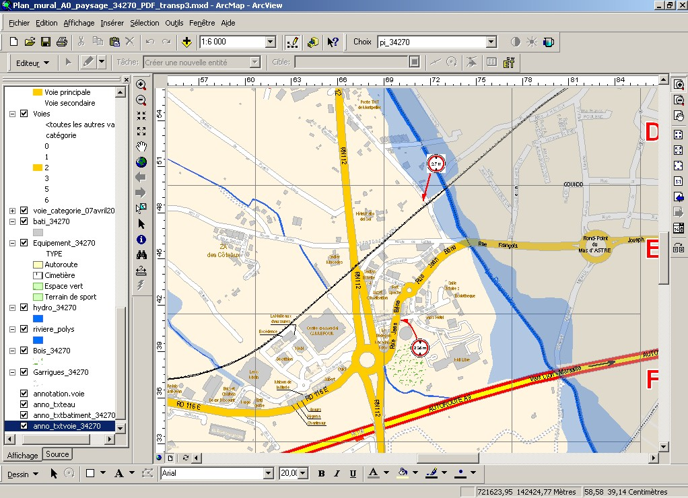
Figure 7: Extract from GIS database: area of potential flooding overlaid on the principal roads and threatened houses

Measurements of prevention defined by the PPRI are required on all construction, work, installations and activity undertaken or in progress. Worked out by the State and annexed in the Local Plan of Town Planning, the PPRI is composed of a map of zones and a detailed set of regulations for each zone with which any new construction must conform. It makes it possible to determine the housing threatened by the risk of flooding. However, it is possible to identify on the ground some flooded zones due to the run-off of rainwater, especially at times of torrential rain which occurs in autumn and spring in the Mediterranean climate and which are not identified in the PPRI. These events occur following the construction in urban areas (of road infrastructure, individual housing estates, zones of economic activity), and in agricultural areas (regrouping, deforestation, grounds left as waste lands). At the moment, GIS is used to represent the flooded areas on a map.
Rapid urbanisation and growth of the road network means that rapid run-off flooding is becoming more and more important. An estimation of urban development was made in the SCOT of the Agglomération de Montpellier (17 February, 2006) showing that for a family wanting to settle in the area, it will be necessary to have a land parcel of at least 400 square metres, and the same surface area for leisure, retailing and network infrastructure. As result, more impermeable land is created which in turn creates more run-off when there is extensive precipitation and more flooding, especially in autumn and spring. This is why firemen are facing more flooded zones in addition to those easily flooded zones that are recorded and mapped. In the Hérault, due to tourism growth, the climate, demographic development, new inhabitants in suburban areas and more extensive vineyard villages, there is an increasing number of areas at risk of flooding. The photograph in Figure 8 illustrates the extent of flooding of the River Les as it passes in front of the Regional Council building at the east end of the Antigone.

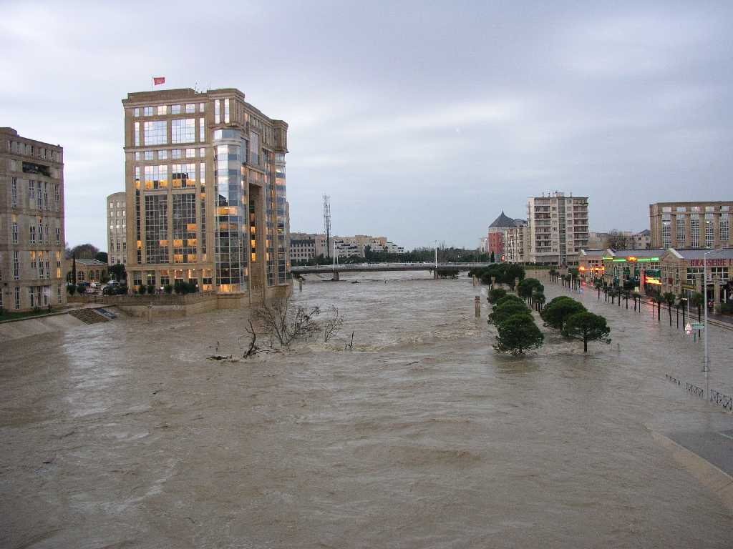
Figure 8: Flooding of the River Les in Monpellier, 2003

Flood risk assessment is relevant to various plans that are produced, including the PLU. It is mainly based on estimation. Due to net population in-migration, building and infrastructure construction is very fast. There is also a concern that climatic change is occurring. Some storms are unpredictable and very strong and sudden. One storm occurred in the south east of Montpellier, between Mauguio and Sommières, on 29 September 2007, which was not predicted by the local weather forecasting office and, although lasting only one hour only, resulted in roads being flooded, houses inundated and telephone connections broken. It is always necessary to establish a rigorous methodology supplemented by investigations on the ground in order to complete the cartographic representations of the different risk zones. More open exchange with all the public administrative services is required and the SDIS should be sharing its GIS data across one network, enabling careful analysis of the occurrence of fire and floods and better general knowledge of how to limit these disasters. Furthermore, the European Union has also defined a ‘Directive on the assessment and management of flood risks’ known as WISE, the Water Information System for Europe (http://ec.europa.eu/environment/water/flood_risk/index.htm). This directive has strengthened international cooperation in shared river basins and has streamlined preliminary flood risk assessment and mapping.
In summary, the use of GIS by the SDIS34 in terms of risk assessment is still at an early stage, with recognition of its value as a map-making tool for identifying areas subject to different degrees of risk of fire or flood rather than its potential value for data analysis, estimation and modelling. The data sets are increasing and the technology and technical know-how are available. The constraint on further development of GIS in this context at the moment is the lack of interest by those in positions of higher authority in the administrative hierarchy to progress important applications.

5 THE FUTURE DEVELOPMENTS OF GIS

One of the important developments in future will be the creation of a GIS network between the 72 fire stations in the Herault département, using the ArcIMS technology created by ESRI. All the geodatabases would be centralised on a remote server at the headquarters in Montpellier. The firemen on operations could have remote access using an internet interface with a login and a password in order to check the addresses of the incident locations and to provide information about them (e.g. a hydrant without water, a new street, a flooded road) that would be sent to the Cartography and GIS service (Hooper, 2006 http://www.cadcorp.com/pdf_downloads/PA-firebrigade_ukv4i5.pdf). The availability of information from the call centre of any fire station about the location of the incident which has been obtained from the GIS coverages, will be an invaluable guide for the firemen attending operations, particularly if the information provides up-to-date details of traffic jams or roadworks, as well as street width, bridge height, flooded areas and new housing construction. All this relevant information would be digitised and included in the GIS in order to be available directly to the fire crews, while the paper atlases would be updated and printed once a year.
The GIS that has been adopted has been used with two aims in mind: automated map making and facilitating the comparison of data on thematic maps (Burrough, 2001). Once the data have been created and stored, the next step is analysis. There is a range of GIS analysis tools available such as clipping, dissolving and merging digital data and there are intersect and union functions that can be applied when overlaying coverages where the data are topologically structured. These functions are being used by the SDIS34 to create data to draw maps, but not for spatial analysis. On the other hand, there are also generic spatial analysis and modelling techniques available that can be used in combination with GIS to analyse the distribution of attribute information. One obvious focus is on understanding the distribution of fire and rescue incidents (Figure 9) and analyzing the spatial relationship between these data and socio-economic indicators such as unemployment or poverty. Here the question is whether there the spatial occurrence of fires and the need for rescue are associated with the socio-economic characteristics of the inhabitants of different parts of the city.

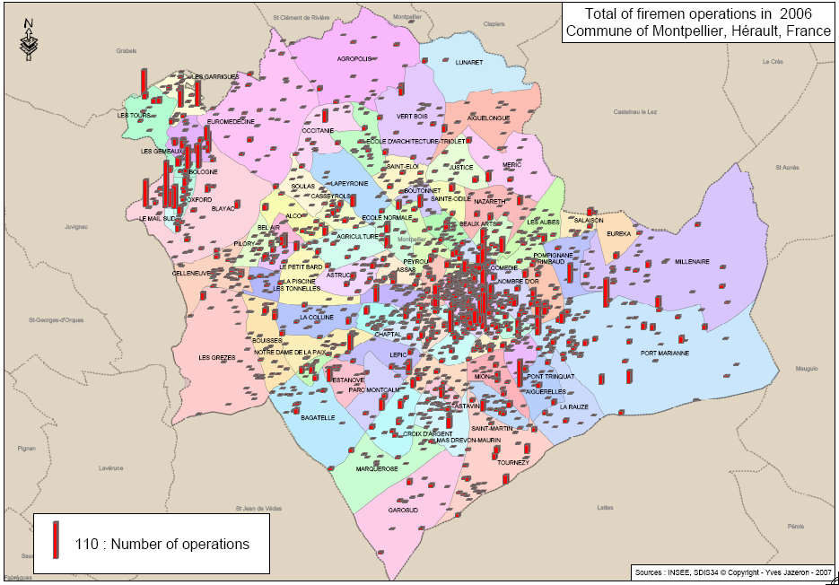
Figure 9: The distribution of fire and rescue operations in the commune of Montpellier, 2006

Socio-economic variables are only available for the neighbourhood areas defined by INSEE as part of IRIS2000 (Ilôts Regroupés pour l’Information Statistique), a database that is available for major towns and cities across France. The spatial units for which data are collected in IRIS2000 are small areas that aggregate into communes. In this instance, we make use of three variables: the unemployment level, the number of people without a diploma and the number of immigrants, all of which are measures whose high values are associated with adverse socio-economic conditions. The rate of unemployment for the commune of Montpellier as a whole was 12.6% in 2006, rising to nearly 40% in two areas in the La Mosson area, Le Petit Bard and Le Mail Sud. The low qualification indicator is the population aged between 25 and 60 who do not have a degree whereas the third variable is a measure of number of immigrants, the vast majority of which come come from the Maghreb.
The ArcGIS coverages provide the background for maps of the spatial distribution of incidents. Figure 9 shows the distribution of operations in 2006 within the commune of Montpellier. A total of 10,342 operations were recorded by the Emergency Call Centre across the city and have been plotted based on the sections of road corresponding to the address of the incident. The incidents can be aggregated to the 82 neighbourhood polygons shown in Figure 9. Visual inspection of the map shows a cluster of incidents on the north-eastern periphery of the commune which is associated with two of the poorest areas of the city, La Mosson and Hauts de Massane. At the opposite end of the spectrum, the most affluent areas of Montpellier including Hôpitaux-Facultés and Aiguelongue do not have many incidents. Although there is a strong concentration of incidents in the town centre, this is likely to be due to the density of housing and population. The scattergraphs of incidents versus each of the three variables are shown in Figure 10, with correlation coefficients of 0.451, 0.295 and 0.298 indicating the level of association in each case respectively. All the coefficients are positive but it is the number unemployed that shows the highest spatial correlation with the number of incidents.

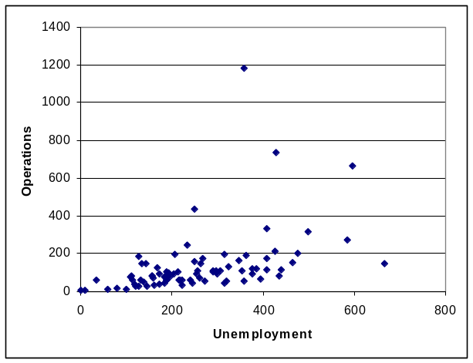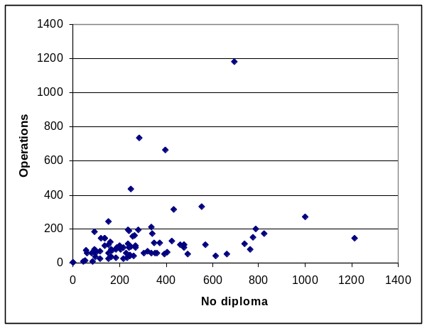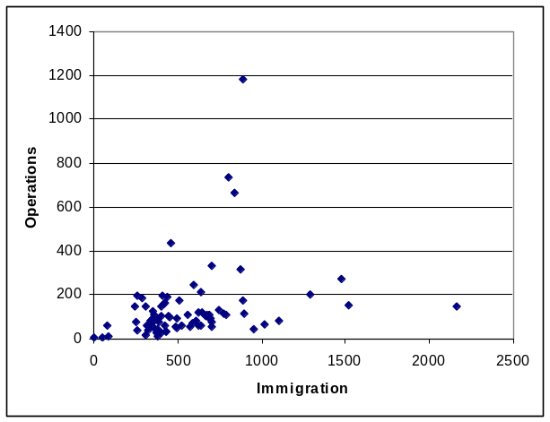
Figure 10: Scattergraphs of incidents with unemployment, no diploma and immigration

6 CONCLUSION

This paper has outlined how GIS is being applied to support the operations of the fire and rescue services in Montpellier. The creation of accurate maps for use in everyday operations has become a vital component in providing a more efficient service. A measure of success has been the demand for atlases by the commune administrators, the utility companies (water, electricity and gas) and the national gendarmerie because of their relative accuracy compared with IGN maps. It is incredible that there is such limited joined-up planning at the local level between the major agencies and authorities in Montpellier who require accurate maps of the road network. Moreover, it is even more disturbing to recognize that there is no formal centralization of the experience and knowledge in France about the optimal method for producing maps for use in fire and rescue services across the country. Every département appears to have its own system (e.g. SIGALE, ARTEMIS, SYSTEL) for providing its fire and rescue service with location information.
In addition to producing maps for operational services, the creation of wall maps has been very beneficial for crisis management, the integration of the database at the Emergency Call Centre has improved the speed of finding the location of each operation on the paper atlas, and has allowed feedback to be given on the data provided. When returning to the fire stations, the firemen report whether the information contained on the maps is incorrect or incomplete. Fortunately, for civil security, this happens rarely. The digitized distribution of hydrants provides the fire crews with immediate information about accessibility to water supplies for fighting fires.
The Tactic Reasoning System Method (MRT) provides a series of analytical steps at different levels, making it possible to understand all the elements of an incident and its environment, and to define the actions to be carried out according to the objectives laid down by taking account all the means available. The reasoning steps are as follows: (i) Where is the incident? Is it a disaster? What tactics are required? (ii) What are the risks and the major problems to avoid? (iii) How is the task to be accomplished? (iv) What means should be used to undertake the task? And (v) according to which rules should the task be undertaken? From the tactical reasoning comes the initial order which will be given to the chiefs of the team of firefighters involved. GIS, as used in the forecast service aims to improve this MRT process by giving as much information as possible to the fire crews before an operation occurs. Data attributes are updated as soon as changes are made; this information come from the urban service of the town concerned and from the field investigations. The maps and the ERs plans provide immediate knowledge of locations that the firefighters can identify at the location of a disaster. Although the applications are not sophisticated, they have become increasingly indispensable to the service in the Hérault.
Similarly, there have been a number of benefits arising from the cartographic exercises that have generated information about the risks associated with particular locations. Details of the location of classified natural risk sites, classified technological risk sites, areas of pollution, safety perimeters and populations at risk of exposure are all very important attributes which the improve safety and enhance knowledge of the situations in which the fire crews have to operate. GIS is not only providing information about the location and type of risk, it aims at reducing the risks by forecasting the urban development. This is why the SDIS34 is working with the local authorities who are creating and modifying their PLUs and the SCOT.
Relatively little systematic analysis of the geographical distributions of the incidents dealt with by the SDIS34 has been previously undertaken. The paper has shown how incident distributions maybe correlated with distributions of socio-economic variables, particularly unemployment, but analysis of this type is in its infancy. This is likely to change in future as time series data are collected and greater understanding of the spatial and temporal patterns of incidents is required by policy makers seeking to identify optimum locations for major new projects as well as making routine decisions about infrastructure and housing developments in harmony with the objectives of the regional and local planning frameworks.

ENDNOTE
The first author wishes to emphasize that this paper contains his own views and does not reflect the views of the Service Départemental d’Incendie et de Secours de l’Hérault.

REFERENCES

Agglomération de Montpellier, www.montpellier-agglo.com
Batcheller, J.K., Gittings. B.M. and Dowers, S. (2007) The performance of vector oriented data storage strategies in ESRI’s ArcGIS, Transactions in GIS, 11(1): 47-65.
Burrough, P.A. (2001) GIS and geostatistics: essential partners for spatial analysis, Environmental and Ecological Statistics, 8: 361-377.
CEMAGREF, 2003, Centre national du machinisme agricole et du génie rural des eaux et forêts, www.cemagref.fr
Center for Research on the Epidemiology of Disasters, may 2005, www.cred.be
Centre d’Essai et de Recherche de l’Entente, www.ceren.org
Code de l’Environnement – Livre V : Prévention des pollutions, des risques et des nuisances – Titre VI – Prévention des risques naturels, www.legifrance.gouv.fr
Entente Interdépartementale en vue de la protection de la forêt et de l’environnement contre les incendies, www.entente-foret.com
ESRI®, (2007) GIS for Fire Station Locations and Response Protocol, an ESRI® White Paper, January, (http://www.esri.com/library/whitepapers/pdfs/gis-for-fire.pdf)
Hooper, R. (2006) London Fire Brigade aims high, GEOconnexion, November/December.
IFEN, Institut Français de l’Environnement, www.ifen.fr
INSEE, Institut National de la Statistique et des Etudes Economiques, www.insee.fr
Kacenelen, Y. (2006) Implementing optimized GIS data collection to supply an emergency management system (France), ESRI User Conference, 10 August.

Mairie de Montpellier, www.ville-montpellier.fr.
Ministère de l’Ecologie et du Développement Durable, 2005 www.ecologie.gouv.fr
November, V. (2003) La Gestion des Risques en Suisse, DATAR.

Lo, C.P. and Young, A.K.W. (2007) Concepts and Techniques in Geographic Information Systems, Pearson Prentice Hall, Upper Saddle River, NJ.

Longley, P., Goodchild, M., Maguire, D. and Rhind, D. (eds.) Geographical Information Systems : Principles, Techniques, Management and Applications, Wiley, New York.

Pôle nouvelle technologie, www.pont-entente.org
Scholten, H.J. and Stillwell, J.C.H. (eds.) Geographical Information Systems for Urban and Regional Planning, Kluwer Academic Publishers, Dordrecht.
Service Prevision Centre de Secours Principal de Montpellier (2009) Atlas Commune de Montpellier Edition 2008, Service Departemental d’Incendie et de Secours de l’Herault, Montpellier.
Stillwell, J., Birkin, M., Ballas, D., Kingston, R. and Gibson, P. (2004), Simulating the city and alternative futures, in Unsworth, R. and Stillwell J. (eds) Twenty-first Century Leeds, Geographies of a Regional City, Leeds University Press, Leeds.
Teng, A., Multiple GIS Databases Support Fire and Rescue Services, (http://www.montgomerycountymd.gov/content/gis/docs/GISnews/dfrs_gis.htm) Montgomery County, Maryland.

